Flight Gear - just another Flight Simulator?

Dr. Michael Basler, Jena

If you think about it, flight simulators for the PC like Microsoft Flight Simulator, ATP or Flight Unlimited, are actually pretty cheap. Compared to the cost of the hardware you need to run them (which is usually quite high-end), the amount asked of you for the program isn't really worth talking about.

Even so, a number of flight sim enthusiasts have come together over the internet to work on their own alternative to these already established programs. The project is called "FlightGear". The plan is for the simulator as well as the source code to be customisable and available for free to anybody who wants it. There's every chance that this can work: past projects like Linux, the GNU C-Compiler and the TeX/LaTeX packets are a testament to this.

With FSFW95 now available for well under 100 DM, it's fair to ask whether it's worth their effort.

To take FS5 again, there's no doubt that a great deal of its popularity is attributable to the many hundred freeware and shareware airplanes, panels and scenery files that are available. All of these are made possible by the painstaking decryption efforts of just a few experienced coders, which at times approaches sheer guesswork. Very rarely do the developers release any information about programming interfaces, known as APIs. The people involved in the Flight Gear Project on the other hand have set themselves the goal of keeping the development of the simulator transparent from beginning to end. All the APIs should be documented, and any that slip through the net should be easy to extract from the source code.

Here's something else to consider: In order to cover their development costs, the "cheap" simulators need to appeal to the mass market. Because of this, they place more worth on special effects and ease of use than on realistic radio communication or getting the right VOR placements and most up-to-date ILS frequencies. Furthermore, with a development cycle of two years or so, it can take a long time before requested modifications are acted upon and implemented. Coming from this angle, implementing features which serious, dedicated Simulator Pilots want would amount to throwing money away.

There's a further reason for the flight sim fans wanting their own simulator. With very few exceptions, most flight simulator software available is designed exclusively for the "Wintel-PC". Microsoft have stopped supporting the Macintosh, and there's really nothing comparable to FS5/FSFW5 available for the various derivatives of Unix (Linux being the ideal derivative for the private consumer). The reason is the same: financially, it's just not worth it.


Ill. 1 The Windows 95 Icon for Flight Gear.

The "Flight Gear Project" was first proposed by the American Dave Murr, then a sixteen-year-old student. However, it wasn't as if this was just the airy-fairy idea of some overeager schoolboy. Dave Murr has been one of the co-publishers of the extremely successful web-zine "FS-News" for the last two years. His ideas were first discussed at length in the rec.aviation.simulators newsgroup and the fltsim@grove.iup.edu mailing list, raising a lot of interest in the process, before the proposal was consolidated in something akin to a mission statement, which was in its third version at the time of writing.

The developers are mainly agreed on the following points:

The program would be freely available under the GNU Public License, without excluding the possibility of a commercial release, possibly on CD. If a CD were released, everybody would be within their rights to simply give it to their friends so that they too could install it for themselves.

--The project as a whole would be divided into different modules, which would be produced by a range of different developers working together over the internet. Once completed, the various modules will be tested and put together. At the moment the plan is to have four of these modules:

a) The interface for generally controlling the program, including the menu system.

b) The development of the airplanes themselves, comprising of the flight models and aircraft panels among other areas.

c) The world outside the cockpit, e.g. static or dynamic scenery, weather and air traffic control.

d) The system-dependant processes such as graphics display, sound setup, running multiplayer sessions over a network, etc.

--The quality of the scenery should be up to at least the quality of FS5. On the other hand, the program should still be able to run well on a 486-66 processor. At the time, the recommended requirements were a Pentium 133 or equivalent, with 1-2 Megabytes of VRAM, a sound card and CD-ROM drive. Quite how neatly these will tie in with the desire for an easily portable code remains to be seen, but it pays to have a vision.

--The emphasis should be laid squarely on general and civil aviation. There are no plans for the program to be a shoot-em-up. With the source code openly available, it is of course perfectly feasible for people to fashion a military simulation out of it if they so wished.

At the moment, six to eight people are actively involved in working on "Flight Gear"; many more have registered on the public developers list. Some aspects of the programming are clear pre-requisites to others; work can only really begin on scenery design once the core code and graphical output are firmly set in place.

It's undecided whether the program will use the *.bgl format that we know from FS5/FSFW95 or a new format will be created. One advantage of doing the former is the instant availability of a wide range of scenery files. At the same time, this would mean accepting the range of inherent restrictions that would come with the *.bgl format.

In any case it will be a while before work commences on scenery design. As the first few weeks and months of conceptual debate come to an end, a few enthusiastic programmers have begun to knuckle down and get on with writing the first of the modules, which should be the basic visual and graphic routines, the keyboard input, etc.

More than anybody else, we have Eric Korpela (University of California, Berkeley) to thank that the basic parts can be compiled and run on pretty much every conceivable platform.

We've gone beyond the stage of just passing morsels of code around by email. We now have an actual, executable program. See illustration 2 for a screenshot.

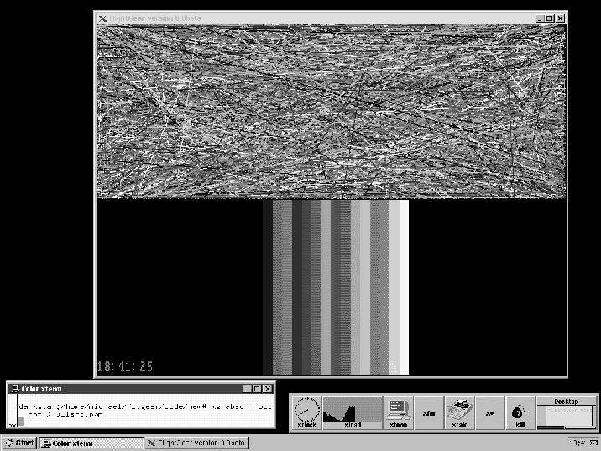
Ill. 2 A screenshot of Flight Gear running under Linux - not quite a fully functioning flight simulator yet, but crucial graphics routines are definitely evident.

The criss-crossed lines in the top half of the screen aren't just static, but rush quickly over the monitor. The speed at which this happens on various systems lets us know what to expect from the refresh rate in the future. The stripes in the lower half make up an early version of a panel. Our most recent achievement is the clock which displays the system time.

Now anybody, with a bit of practice, should be able to use this to help them fly the standard two minute 360° rotation...

Meanwhile, work is continuing on other, related modules. Curtis Olson (University of Minnesota, Minneapolis) has disassembled the freely distributed UNIX military flight simulator ACM and modified certain core components for our purposes. I have put together an installation guide. Further information on the developers, the modules, the current state of development, the overall concept of the project and much, much more can be found on the Flight Gear homepage:

http://www.menet.umn.edu/~clolson/fgfs/

I'm sure that by the time this article is published, development will have marched on apace.

If you like getting your hands dirty with unfinished programs, you can download the most up-to-date sections of code from the website. You'll also find fully compiled and runnable versions for DOS and LINUX (ELF) on the server along with the complete source code. If you have the GNU C-Compiler installed on your computer, you could try and compile Flight Gear yourself with the help of my installation guide. Perhaps you'll enjoy it so much that you'll want to help with the development yourself.

Playing around with code isn't everybody's cup of tea of course. Most readers of FSFD would just want to get on and fly. So let me make this clear: we won't be seeing the finished "Flight Gear Simulator", comparable in kind to FSFW95, before this article appears. This leaves us with one final question: when will we be able to fly in Flight Gear? Answers vary wildly. Pessimists look at the amount of time it took to develop FS5 and come back with an estimate of 10 years. The optimist camp would have us believe that we'll be flying over basic scenery in half a year. My advice to you is to check in on us in half a year. If things are still going as well then as they are now, maybe you'll really be able to take off in Flight Gear.

